|  |  |  |  |  |  |  |  |  |  |
| --- | --- | --- | --- | --- | --- | --- | --- | --- | --- |
| ACTIVITY DESCRIPTION | STEP | INSPECTION FUNCTION | APPLICABLE STANDARD | ACCEPTANCE CRITERIA | SWMS | VAST INSPECTION | SIGNATURE | DATE | RECORDS/ REMARKS RESULTS |
| CABLE INSTALLATION |  |  |  |  |  |  |  |  |  |
| MEASURE CABLE RUNS WITH APPROPRIATE ACCURATE MEASURING INSTRUMENT EG TAPE MEASURE, WHEEL, ROPE IN CONDUIT | 1 | MEASURE | AS ELEC. DRAWINGS | AS INSTALLED CONDUITS, CABLE TRAYS |  |  |  |  |  |
| CHECK CABLE SIZES. RESISTANCE OF PROTECTIVE EARTH CONDUCTOR SHALL BE LOW ENOUGH TO PERMIT PASSAGE OF CURRENT NECESSARY TO OPERATE PROTECTIVE DEVICE.  *RULE 1.11.2.2. *RULE 1.7.4.3.4. | 2 | CHECK ELECTRICAL DRAWINGS OR SPECS. | AS/NZS  3000:2007  AS 3008 | COMPLIES WITH REGULATIONS |  |  |  |  |  |
| CONFIRM LENGTH OF CABLE | 3 | CORRECT SIZE. LENGTH | N.A. | N.A. |  |  |  |  |  |
| INSTALL CABLE IN APPLICABLE METHOD EG. CABLE STANDS, ELECTRIC WINCH, PULLEYS ETC. ANY CABLE NOT TERMINATED IMMEDIATELY MUST HAVE THE ENDS TAPED COVERING THE BARE COPPER. | 4 | MOST APPROPRIATE METHOD | OH & S GUIDELINES & TAPED ENDS | COMPLIES |  |  |  |  |  |
| TREFOIL (REFER TO DETAILS ON BACK FOR ALL OPTIONS) CABLES AND TIE CABLES TO SUPPORT SYSTEM | 5 | ENSURE SPACING | AS/ NZS  3000:2007 | COMPLIES WITH REGULATIONS |  |  |  |  |  |
| CHECK REQUIREMENTS FOR CABLE IDENTIFICATION AND INSTALL | 6 | CHECK METHOD | AS PER SPEC | COMPLIES |  |  |  |  |  |

SEE REVERSE SIDE

SINGLE CORE CABLES IN PARALLEL

To ensure the best possible degree of load sharing between parallel circuits of single core cables, several arrangements which maintain electrical symmetry are used.

The recommended configuration is close trefoil formation with each trefoil containing three phases:

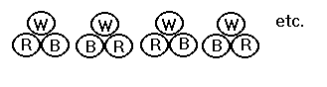

For any reason it is desired to install the cables in flat formation. It should be noted that unequal impedances will exist and load sharing will be unequal. To reduce inequality of load, the following configurations are advised for parallel circuits in flat formation:

Two 3 Phase Circuits

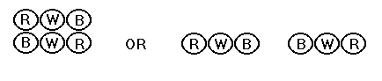

Three 3 Phase Circuits

Three circuits should be laid in trefoil formation as symmetry is not possible using flat formation.

Four 3 Phase Circuits

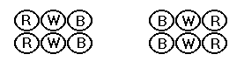

Refer to regulation 3008 Appendix A

NON PREFERRED METHOD

Note: If running cables in flat formation of the same phases, non metallic saddles or straps should be used as metallic straps or saddles will cause induction.

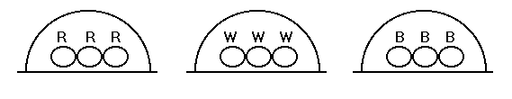

Note: Non Metallic saddles only to be used.